Interventional Pulmonology
Tracheobronchomalacia: Patient Information
Tracheobronchomalacia (TRAY-kee-oh-BRONK-oh-ma-LAY-sha), or TBM, is an uncommon condition characterized by softening of the airway (windpipe) and it starts to become more narrow than it should. The cause of this is unknown but is frequently associated with common conditions such as asthma, gastric reflux (gastro-esophageal reflux disease, or GERD) and COPD (chronic obstructive pulmonary disease).
Image 1: A) Normal trachea [Top – CT image, bottom left – illustration, bottom right – bronchoscopy imaging] B) Tracheobronchomalacia. Courtesy of S. Gangadharan, MD

Courtesy of S. Gangadharan, MD
SYMPTOMS:
People with TBM may have:
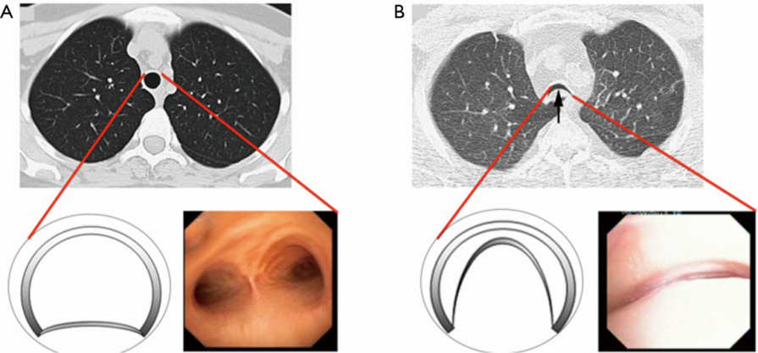
- cough
- shortness of breath
- wheezing
- inability to clear secretions
- frequent respiratory infections
DIAGNOSIS:
A series of tests (Image 1) are done to diagnose TBM. These tests are designed to find out more about the structure of your airways and how it may be affecting your breathing.
A.
B.
- Bronchoscopy – looking into your airways with a small camera.
- A computed tomography scan (CT, or “CAT” scan) – Pictures taken using x-rays and computers while you follow instructions to breathe in and out and hold your breath.
- Pulmonary function tests (PFTs) – Breathing tests that give information on how your lungs are working.
- Six minute walk test – A way to see how your body responds to simple exercise.
- Completion of cough, dyspnea and quality of life questionnaires are administered to quantify symptoms and their impact on your daily life.
- If there is evidence of significant TBM, a stent trial will be performed.

TREATMENT:
Current treatments include medical management and surgery called a tracheobronchoplasty (TRAY-kee-oh-BRONK-oh-plasty). This surgery involves sewing a mesh to the outside of your trachea which requires hundreds of stitches to fasten the mesh to the back of the windpipe (Image 2). The mesh provides structure to the airway making it less likely to collapse.
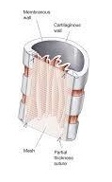
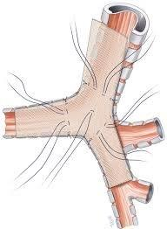
Image 2: Tracheobronchoplasty.
Courtesy of S. Gangadharan, MD

Medical management aims to minimize symptoms and complications associated with excessive airway collapse. These include hand held airway clearance devices (flutter or Acapella valve) which uses airway vibrations to mobilize mucus as well as CPAP (continuous positive airway pressure). CPAP is a device traditionally used for obstructive sleep apnea and worn at night using pressure to push air into your lungs. Mucolytics help to thin secretions such as Mucinex and Acetylcystiene which often help mobilizing mucus. Finally, maximizing medical therapy for other conditions which can also worsen your breathing such as GERD, asthma/COPD, post nasal drip, vocal cord dysfunction, obesity and decreased immune function is essential in the care of patients with TBM.
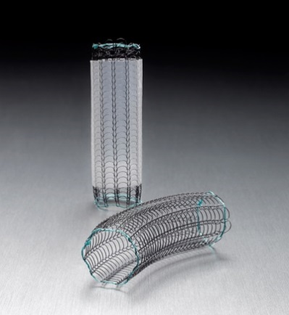
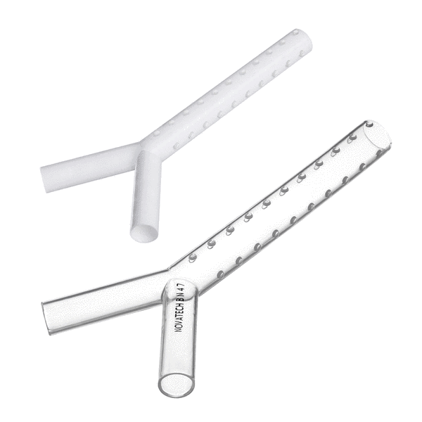
Image 3: Silicone Y stents. © Novatech SA, France
Image 4: Covered and Uncovered metal stent.
© Boston Scientific Corporation

AIRWAY STENT TRIAL: Your doctor may consider a bronchoscopy with temporary placement of a stent(s). A stent is a small plastic (Image 3) or metal tube (Image 4) that is placed in your airway during a bronchoscopy to hold your airway open. The stent trial typically lasts 1-2 weeks. The stent cannot stay in permanently as long-term use can be associated with complications including infection and scar tissue formation in the airway. During the stent trial we will evaluate you for both subjective and objective signs of improvement of your breathing. If symptoms improve you will be considered a candidate for surgical treatment. If unclear or if the stent did not help your breathing, medical management will be continued.

