Interventional Pulmonology
Airway Stenting: Patient Information
Stents can be used to treat blockages or narrowing in the airway caused by multiple diseases when surgical correction is not an option. Stents can improve respiratory symptoms, quality of life and exercise capacity in select patients. Occasionally, stent trials are performed to identify patients who would benefit from surgery.

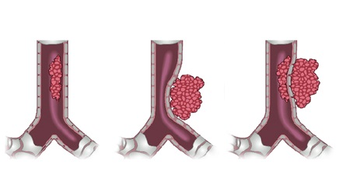
REASON FOR AIRWAY STENTING:
There are several indications such as blockage of the airway by cancerous or non-cancerous tumors, compression of the airway by a mass (Image 1), airway narrowing (scarring), excessive airway collapse, and idiopathic (unknown cause). Symptoms associated with airway problems listed above include shortness of breath, cough, wheeze and stridor.

Image 1: Airway narrowing by tumor. Courtesy of Dr. E Folch
CHARACTERISTICS OF AIRWAY STENTS:
Stents are made of different materials and are available in many sizes and shapes. They are hollow tubular structures that are either cylindrical or Y shaped. There are three different groups based on the material in which they are made: silicone (Image 2), metallic (Image 3), and hybrid (includes both silicone and metal). The stent chosen to be placed in the airway depends on the reason why the stent is being placed. The specific shape and material provide different advantages and disadvantages in opening up the airway and are often decided upon in the operating room based on the airway shape, size and location of the blockage.

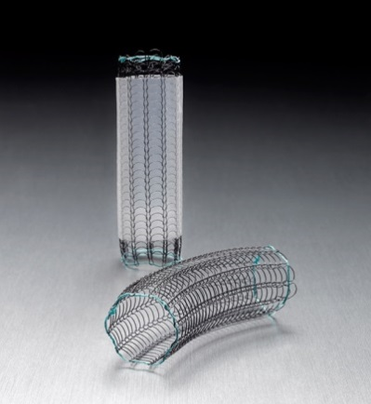
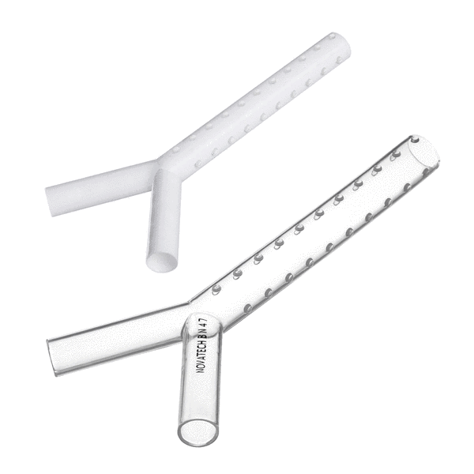
Image 2 [Left]: Silicone Y stents. © Novatech SA, France

Image 3 [Right]: Covered and Uncovered metal stents. © Boston Scientific Corporation

PROCEDURE:
In order to place the airway stents safely, patients are made comfortable with general anesthesia and a special breathing tube is used called a rigid bronchoscope. At times fluoroscopy (specialized x-ray) will be used in addition to bronchoscopy to aid in positioning and confirming stent placement.

COMPLICATIONS:
Most common complications include:
- Mucus plugging
- Scar (granulation) tissue formation
- Infection

HOME CARE:
In order to minimize these complications the patient should follow a strict home airway stent protocol which includes medications such as mucolytics which thin secretions, airway clearance devices (flutter or Acapella valve) which uses airway vibrations to mobilize mucus, maintain adequate hydration and medications to suppress cough if appropriate. These are often modified depending on the patient’s symptoms.

Instructions listed below are considered general care while the airway stent is in place:
Mucolytics: Guafenesin 1200mg twice daily
Mucomyst (N-Acetylcysteine) 6 to 10 mL nebulized twice daily
Albuterol Sulfate 2.5 mg/3 mL solution nebulized twice daily
Flutter valve (Acapella) twice daily and PRN congestion
Cough suppression: Codeine-Guaifenesin liquid 5-10mL every 6 hours as needed

OUTCOMES:
Most patients will have a significant improvement in their breathing. This is seen in approximately 80% of patients who have a non-cancerous blockage and 70% of patients with a airway obstruction caused by cancer.

FOLLOW-UP:
The follow-up time is variable and depends on the patient’s illness and relief of symptoms following the stent placement. Further evaluation typically requires repeat bronchoscopy as well as CT/CAT (computerized axial tomography) scan imaging to help determine whether or not a stent should remain in place or be removed.

A stent card will be provided after an airway stent is placed. It should be carried and shown to all healthcare providers involved in the patients care.

If you have any trouble breathing or any signs of infection you must call the Chest Disease Center for further instructions or seek immediate medical attention by calling 911.
If you have any questions or concerns, please call our office at 617-632-8252.

