Interventional Pulmonology
Pleuroscopy: Patient Information
Pleuroscopy is a procedure in which a physician can view the chest cavity and the lungs by inserting a thin tube between the ribs through the chest wall. This tube, called a pleuroscope, is a specialized instrument that contains a light and a camera attached to a video monitor.

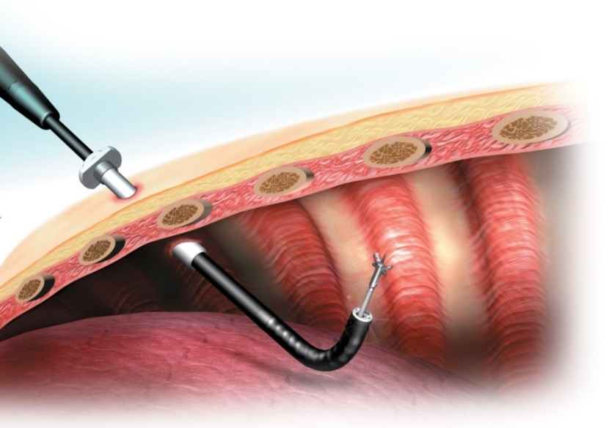
REASON FOR PLEUROSCOPY:
With a pleuroscope (Image 1) the doctor can examine and diagnose problems in the chest, obtain tissue samples, drain fluid and administer treatments to prevent fluid from returning. When indicated this procedure is an alternative to open chest surgery. It is less painful than surgery and often requires fewer days in the hospital and less recovery time.
Image 1: Pleuroscope in the pleural space. Courtesy of Olympus America Inc.
PREPARATION:
Do not eat or drink anything after midnight the night before the procedure. You may still take your morning medications with sips of water. Any use of blood-thinners, such as Warfarin, Lovenox, Plavix, etc., should be discussed with your doctor or nurse a week before the procedure as they may need to be stopped. If you take medication for diabetes, do not take them the morning of the procedure. The procedure is done in the operating room and takes approximately one hour. Plan to be admitted to the hospital following your procedure.
PROCEDURE:
You will be registered and prepared for the procedure by one of our pre-op nurses in the holding area. When the procedure team, room and equipment are ready you will be wheeled into the operating room on a stretcher. You will be given oxygen throughout the procedure using a nasal cannula or a mask and we will monitor your oxygen levels. In some cases, we will deliver oxygen through a tube directly into your windpipe. You will be given a sedative and pain medication through an IV to make the procedure more comfortable. The procedure will be done while you are lying on your side and the pleuroscope will be inserted through one or two small incisions between your ribs. Your doctor will obtain tissue samples and/or complete previously discussed interventions. A drainage tube will be left at the incision site to allow for any fluid or air to drain from the chest. The tube may be removed within hours or it may need to remain in the chest cavity for several weeks. It is safe to go home with the tube and can be drained by a visiting nurse.
COMPLICATIONS:
Pleuroscopy is a safe and effective procedure to diagnose and treat several diseases that affect the lining of the lung.
Potential complications include:
- Pain is common particularly when talc is sprayed within the chest cavity. We will treat your pain during your hospital stay if needed.
- Fever (>100.4 F) within the first 24 hours is common but if persists it could suggest you have an infection and your doctor should be notified.
- Bleeding is usually minor and stops without treatment. Major bleeding is rare and may require a surgical procedure.
FOLLOWING THE PROCEDURE:
- You will be transferred to a recovery area where you will be monitored for two to three hours and a chest x-ray will be obtained.
- Depending on your doctor’s recommendation you may be discharged home or you may need to stay in the hospital for additional observation and treatment.
- If discharged from the recovery area you must have a ride home. You may not drive the day of the procedure due to the sedatives/anesthesia you have received.
- After your chest tube has been removed the dressing should stay in place for 72 hours and the stitches are to be removed in 10-14 days if they are not absorbable.
- If you are discharged home with a tunneled pleural catheter (chest tube) in place nursing services will be set up by a case manager for drainage of pleural fluid in your home.
- Before you leave the hospital, you should receive a date and time for a follow-up appointment.
- If biopsies were collected results will be available in 7-10 days.
Please call us at 617-632-8252 with any questions.

